Module 4) CSS and CSS 3

1) What are the benefits of using CSS?
Answer : The main benefits of using CSS include improvement over format control, site maintainability, accessibility, page-download speed, and output flexibility.
1) Faster Page Speed. More code means slower page speed.
2) Better User Experience. CSS not only makes web pages easy on the eye, it also allows for user-friendly formatting.
3) Quicker Development Time.
4) Easy Formatting Changes.
5) Better Device Compatibility.
6) Flexible positioning of desing elements.

2) What are the disadvantages of CSS?
Answer : With CSS, what works with one browser might not always work with another. The web developers need to test for compatibility, running the program across multiple browsers. There exists a scarcity of security.
1) Limited security.
2) Extra work for developers.
3) Positioning of Design Elements.
4) Takes time to formet.
5) Confusion due to many CSS levels.
6) Cross-Browser Issues.

3) What is the difference between CSS2 and CSS3?
Answer : CSS3 has compatibility with external font styles through google fonts and typecast.CSS3 has its specifications divided into many individual modules, which makes CSS3 a whole lot easier to handle. With CSS3, the designers can now use special fonts, like those available
CSS does not feature advanced effects like shadowing text, text animation, etc. in CSS. CSS3 has multiple features like text shadows, visual effects, font styles, and colors. In CSS, one can add background colors to and set images for list items.

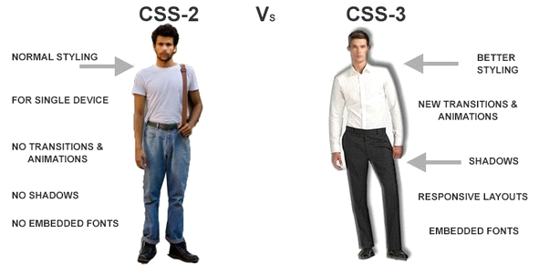
4) Name a few CSS style components ?
Answer : Properties: These are human-readable identifiers that indicate which stylistic features you want to modify. For example, font-size , width , background-color .
Selector: class name, id name or element name that is target.
Attribute: name of the attribute you want to style for example border, color,background, position etc.
Value of Property: value that will be assigned to attribute.

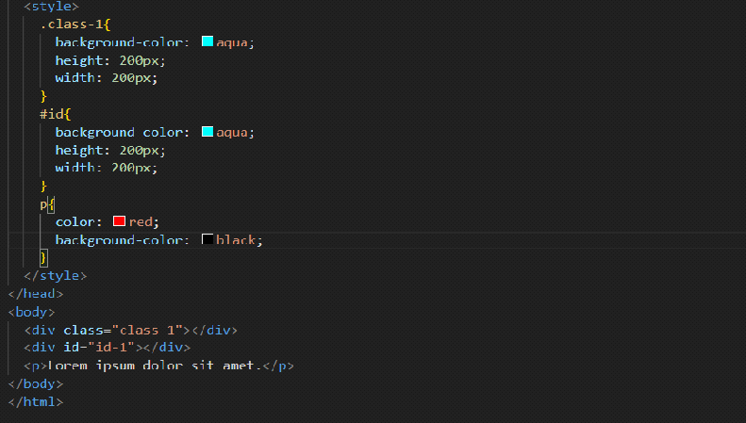

5) What do you understand by CSS opacity?
Answer : Opacity is the degree to which content behind an element is hidden, and is the opposite of transparency. In simple word, you can say that it specifies the clarity of the image. In technical terms, Opacity is defined as degree in which light is allowed to travel through an object.
Opacity. The CSS opacity property sets the opacity for the whole element (both background color and text will be opaque/transparent). The opacity property value must be a number between 0.0 (fully transparent) and 1.0 (fully opaque).

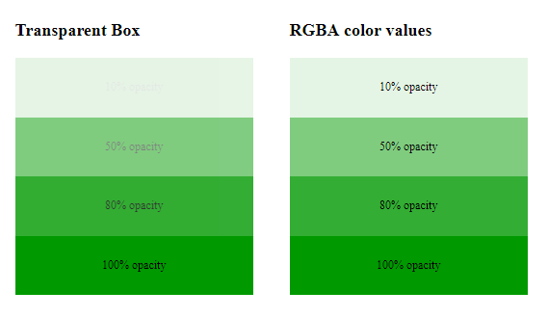

6) How can the background color of an element be changed?
Answer : We can set background color by selecting the element by its class name of id name and then apply the background-color property on it to set the background color
Then add this style attribute to an HTML element, like a table, heading, div, or span tag.
A div is a container element that’s commonly used to designate different sections of a webpage.
Changing the background color of a div is identical to changing the background color of your web page’s body.
Usually, a web page will have many divs. In this tutorial, we’ll teach you how to change one div only.
Let’s go through the process step-by-step
If we want to change the background color of the table, we can use inline CSS to target that single element.
Ex: <table style="background-color:red">
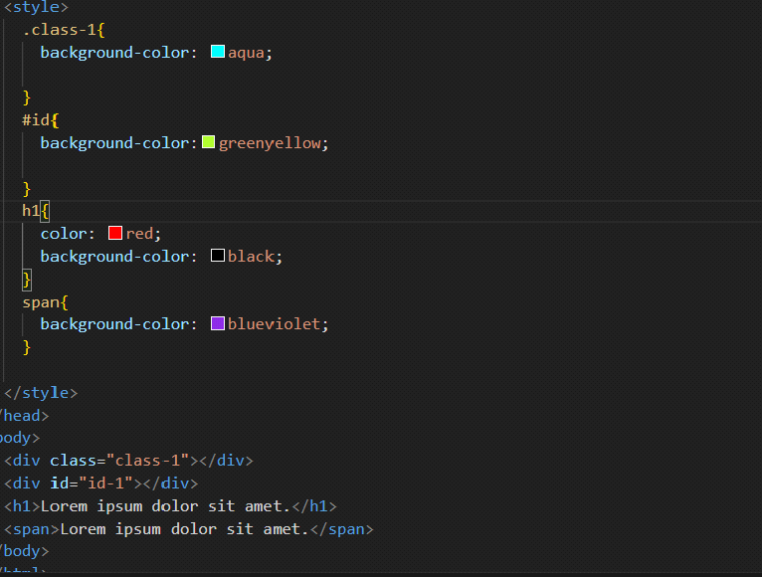

7) How can image repetition of the backup be controlled?
Answer : The background-repeat property in CSS is used to repeat the background image both horizontally and vertically.To control the repetition of an image in the background, use the background-repeat property. You can use no-repeat value for the background-repeat property if you do not want to repeat an image, in this case, the image will display only once.
repeat: This property is used to repeat the background image both horizontally and vertically.
repeat-x: This property is used to repeat the background image horizontally.
repeat-y: This property is used to set the background image repeated only vertically.
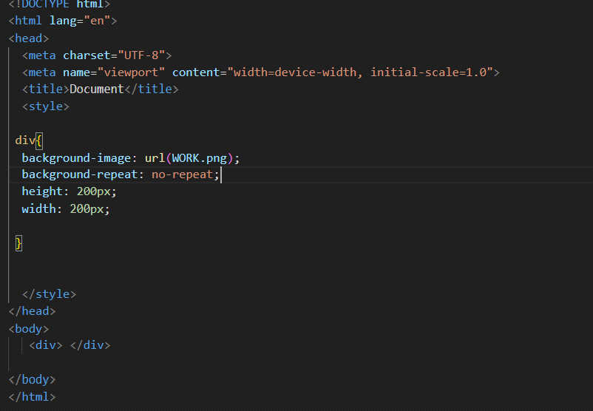
8) What is the use of the background-position property?
Answer : The background-position property sets the starting position of a background image. Tip: By default, a background-image is placed at the top-left corner of an element, and repeated both vertically and horizontally.
If a background image has been specified, this property specifies its initial position. Values have the following meanings: <percentage> <percentage> With a value pair of '0% 0%', the upper left corner of the image is aligned with the upper left corner of the box's padding edge.
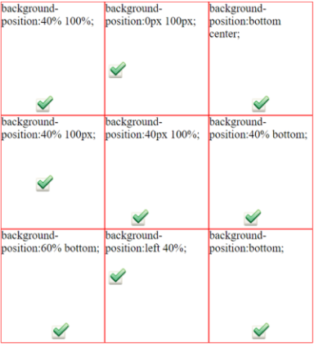

9) Which property controls the image scroll in the background?
Answer : The background-attachment property in CSS is used to specify the kind of attachment of the background image with respect to its container. It can be set to scroll or make it remain fixed. To keep your background image fixed, you have to use the background-attachment property with the value Fixed.
This property has three values scroll, fixed, and local. Its default value is scroll, which causes the element to not scroll with its content. The local value of this property causes the element to scroll with the content. If we set the value to fixed, the background image will not move during scrolling in the browser.
Syntax: background-attachment: fixed;

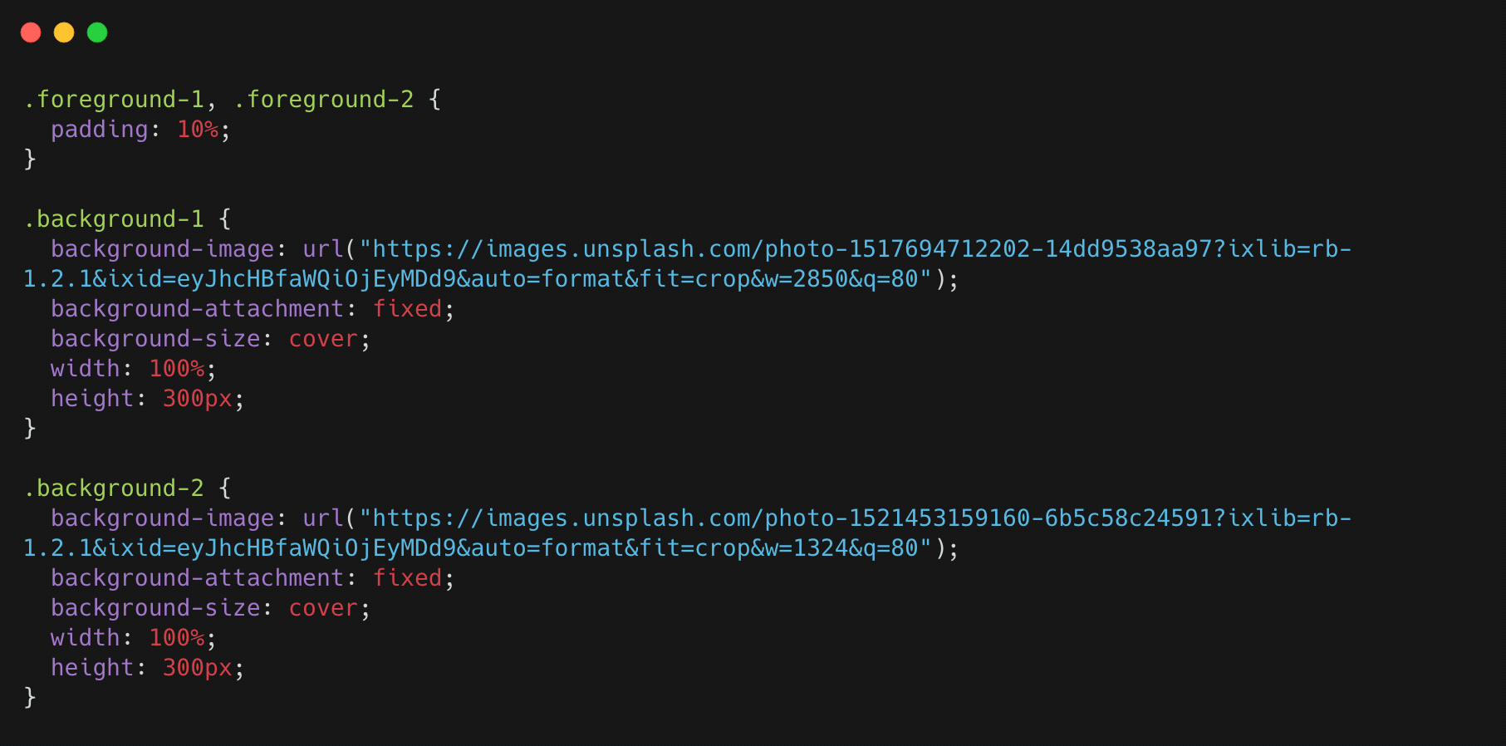

10) Why should background and color be used as separate properties?
Answer : Background and color are separate properties because they can be used for different purposes. The background property is used to set the background color or image of an element, while the color property is used to set the text color of that element. These properties can be used together to create a cohesive design, but they can also be used separately to create different effects.
For example, you might want to set a background color for an element but leave the text color as the default.
The CSS color is used to change the text color of a html element. In this example "This is my text" would be red. The CSS background-color is used to change the background color so in this case you would get a black box with red text inside it.

11) How to center block elements using CSS1?
Answer : To centrally align the block elements, we can simply make use of the <center> tag.
There are two ways of centering block level elements:
1. By setting the properties margin-left and margin-right to auto and width to some explicit value:
BODY {width: 30em; background: cyan;}
P {width: 22em; margin-left: auto; margin-right: auto}

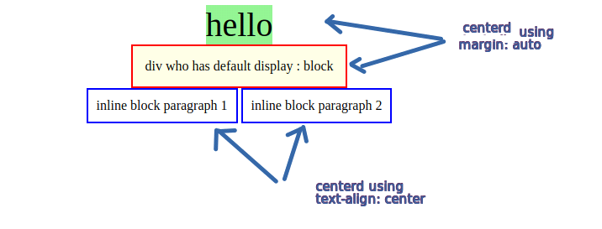

12) How to maintain the CSS specifications?
Answer : To maintain CSS specifications effectively, you can follow these simple guidelines with HTML and CSS code examples:
                - Use Clear and Descriptive Class Names:
                - Use meaningful class names that describe the purpose of the styles.
                - Keep class names consistent and organized.
2. Separate Styles into External CSS Files:
                - Create an external CSS file for your styles (e.g., styles.css) to keep them organized.
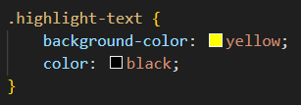
3. Group Related Styles:
                - Group styles together for elements with similar properties.
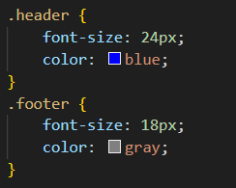
4. Use Comments for Clarity:
                - Add comments to your CSS code to explain the purpose of specific styles.
5.Create a Style Guide:
                - Develop a style guide or documentation that documents your CSS specifications and usage guidelines.
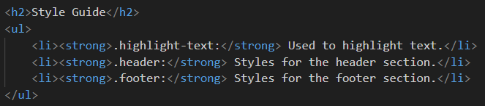
6. Regularly Review and Refactor:
                - Periodically review your CSS code to identify redundant or unused styles.
                - Refactor your code to remove unnecessary styles and improve readability.
7. Use Version Control:
                - Use version control systems like Git to track changes to your CSS files. This helps with collaboration and version history.
->By following these practices, we can maintain our CSS specifications in a clear and organized manner, making it easier to manage and update our styles as our web project evolves.
d
13) What are the ways to integrate CSS as a web page?
Answer : There are three different ways to use css in your web page.
CSS may be added to HTML in three different ways. To style a single HTML element on the page, use Inline CSS in a style attribute. By adding CSS to the head section of our HTML document, we can embed an internal stylesheet. We can also connect to an external stylesheet that separates our CSS from our HTML.
1) Inline CSS : Style rules can be applied to individual HTML elements using inline CSS. The inline styles will only affect the HTML element to which the style attribute with CSS-property values is applied. The first paragraph in the example below will be styled in red with a 20px font size. The properties apply just to the first line of the code, not the full code.
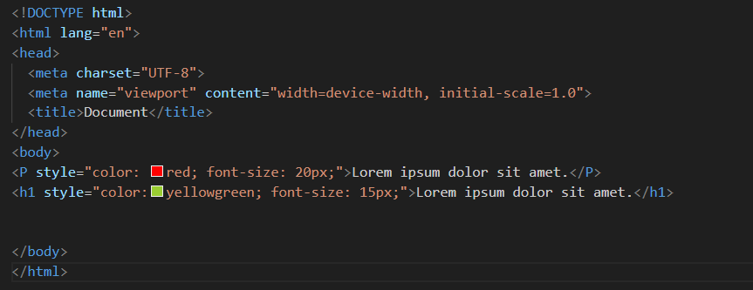

2) Internal CSS : Internal CSS is one of the most popular CSS forms for updating, customizing, and modifying a single web page's unique styles. You can use the internal CSS by integrating the <style> element in the <head> section of a HTML web page.
Internal CSS can be used to style a single web page, but not multiple web pages, and we can style numerous web pages with the same code.
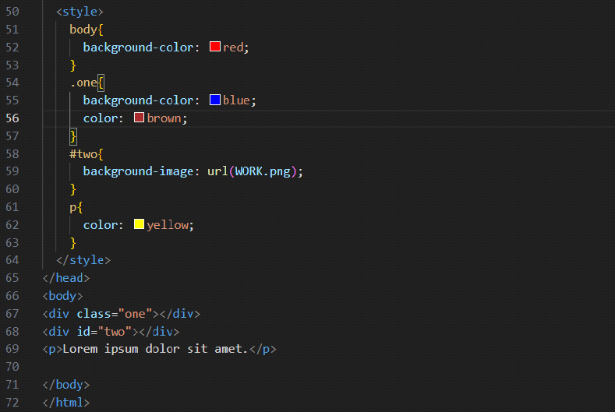

3) External CSS
External CSS is one of the most often used CSS forms for updating, styling, and adjusting the different styles in a large number of HTML web pages at the same time. There are two ways to include an external style sheet in an HTML document. One method is to use the <link> tag in the HTML document head. Another option is to use a combination of external CSS functions and integrated CSS.
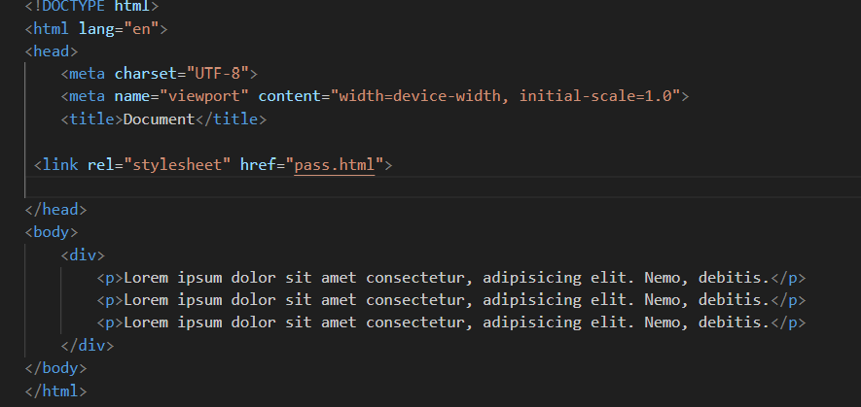

14) What is embedded style sheets?
Answer : Embedded Stylesheet: It allows you to define styles for a particular HTML document as a whole in one place. This is done by embedding the <style></style> tags containing the CSS properties in the head of your document. Embedded style sheets are particularly useful for HTML documents that have unique style requirements from the rest of the documents in your project. However, if the styles need to be applied across multiple documents, you should link to an external style sheet instead of using individual embedded style sheets. Using embedded stylesheets holds a distinct advantage over inline styles which only allow you to address one HTML element at a time.
Syntax: The CSS syntax for embedded style sheets is exactly the same as other CSS code, apart from the fact that it is now wrapped within the <style></style> tags. The <style> tag takes the ‘type’ attribute that defines the type of style sheet being used (ie. text/CSS).
When the list of CSS rule sets is inserted in the style element, it will apply the associated properties to all elements on the web page. In case you want to be more selective and distinctly style an element or a group of elements, use classes and IDs, as shown below.

15) What are the external style sheets?
Answer : An external style sheet is a separate CSS file that can be accessed by creating a link within the head section of the webpage. Multiple webpages can use the same link to access the stylesheet. The link to an external style sheet is placed within the head section of the page.
To apply a rule to multiple pages, an external style sheet is used. An external style sheet is a separate CSS file that can be accessed by creating a link within the head section of the webpage. Multiple webpages can use the same link to access the stylesheet.
1) one change to the style sheet will change all linked pages
2) consistent look and feel across multiple web pages
3) improved load times because the css file is downloaded once and applied to each relevant page as needed

16) What are the advantages and disadvantages of using external style sheets?
Answer :
advantages :
1) Faster page loading: Because the style rules are stored in a separate file, the browser can cache that file and load it more quickly when a user visits multiple pages on your site.
2) one change to the style sheet will change all linked pages.
3) With the help of External Style Sheets, the styles of numerous documents can be organized from one single file.
4) In External Style Sheets, Classes can be made for use on numerous HTML element types in many forms of the site.
5) In complex contexts, Methods like selector and grouping can be implemented to apply styles.
disadvantages :
1) Dependency on the file: If the external style sheet file is deleted or moved, your website's styling will be affected.
2) Less flexibility: With an internal style sheet, you can target specific elements on a page using inline styles. This is not possible with an external style sheet.
3) The execution of the file may be deferred till the external style sheet is loaded.
4) While implementing style sheets, we need to test Web pages with multiple browsers in order to check compatibility issues.
5) There might be cross-browser issues while using CSS.

17) What is the meaning of the CSS selector?
Answer : A CSS selector is the first part of a CSS Rule. It is a pattern of elements and other terms that tell the browser which HTML elements should be selected to have the CSS property values inside the rule applied to them.The element or elements which are selected by the selector are referred to as the subject of the selector.
Class Selector : The .class selector selects elements with a specific class attribute. To select elements with a specific class, write a period (.) character, followed by the name of the class. You can also specify that only specific HTML elements should be affected by a class.
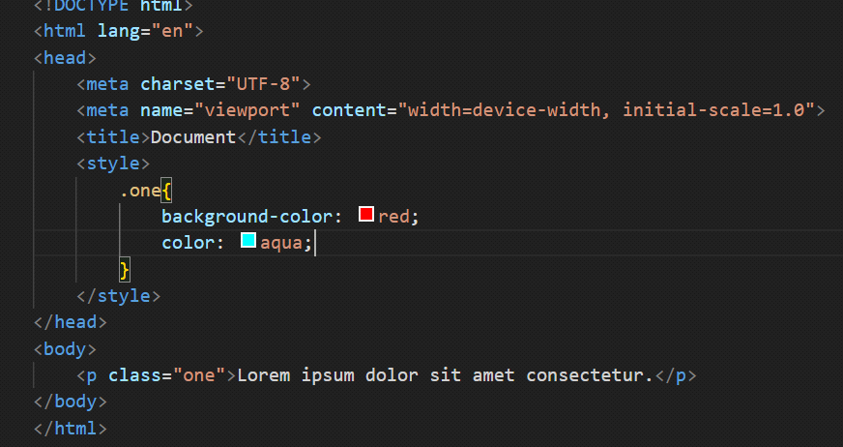
ID Selector : An ID selector begins with a # rather than a dot character, but is used in the same way as a class selector. However, an ID can be used only once per page, and elements can only have a single id value applied to them. It can select an element that has the id set on it, and you can precede the ID with a type selector to only target the element if both the element and ID match.
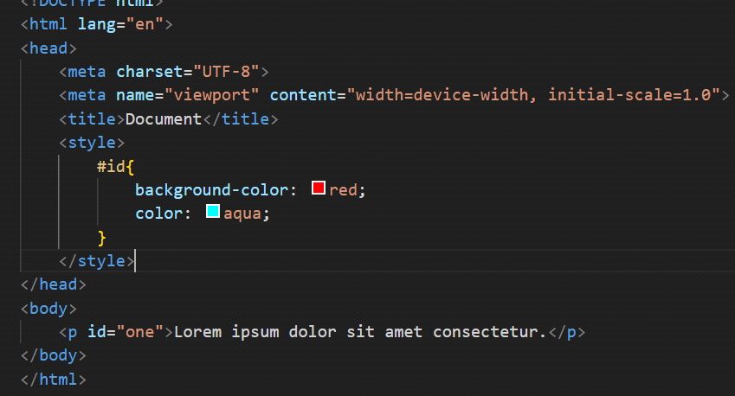
Pseudo Class Selectoer : CSS pseudo-classes are used to add styles to selectors, but only when those selectors meet certain conditions. A pseudo class is expressed by adding a colon (:) after a selector in CSS, followed by a pseudo-class such as "hover", "focus", "active"," visited","first-child",or,"nath-child"
The :current CSS pseudo-class selector is a time-dimensional pseudo-class that represents an element or the ancestor of an element that is currently being displayed. For example, this pseudo-class can be used to represent a video that is being displayed with captions by WebVTT
When a user points to an object on a web page with a mouse, it's helpful if that object responds in some way. For example, when a user hovers over a link, the color and background-color of that link could be reversed.
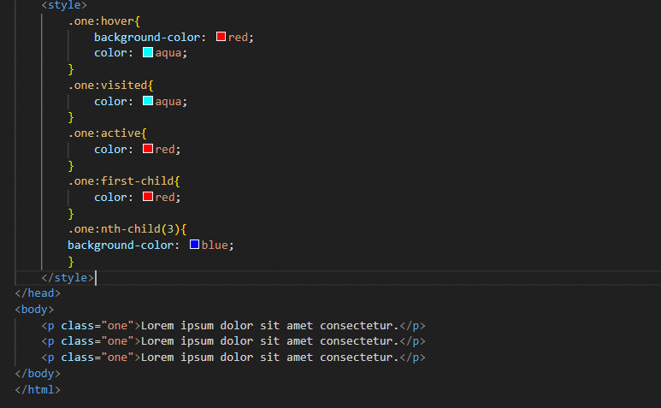
Pseudo Element Selectoer : A CSS pseudo-element is used to style specified parts of an element. For example, it can be used to: Style the first letter, or line, of an element. Insert content before,selection, or after, the content of an element.
A pseudo-class can be defined as a keyword which is combined to a selector that defines the special state of the selected elements. Unlike the pseudo-classes, the pseudo-elements are used to style the specific part of an element, whereas the pseudo-classes are used to style the element.
::first-letter (:first-letter) : It selects the first letter of the text.
::first-line (:first-line) :It styles the first line of the text.
::before (:before) :It is used to add something before the element's content.
::after (:after) :It is used to add something after the element's content.
::selection :It is used to select the area of an element that is selected by the user.
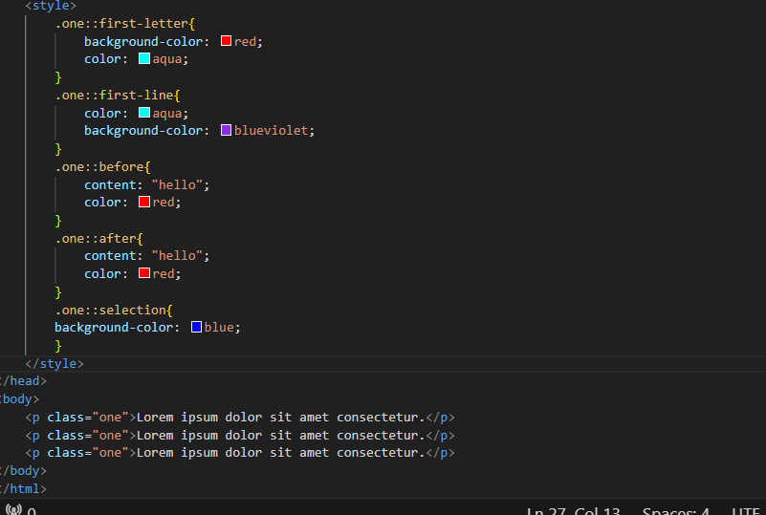

18) What are the media types allowed by CSS?
Answer : A Media query is a CSS3 feature that makes a webpage adapt its layout to different screen sizes and media types.
In the past, building a website was much simpler. Today a website’s layout should adapt itself not only to computers, but also tablets, mobile devices.
Media Query is a popular technique that enables to deliver a style sheet to different devices which have different screen sizes and resolutions respectively. They are used to customize the appearance of a website on multiple devices. A media query consist of a media type that can contain one or more expression which can be either true or false. The result of the query is true if the specified media matches the type of device the document is displayed on. If the media query is true then the style sheet is applied.
The screen resolutions of different devices are listed below:

1) Mobile (Smartphone) max-width: 450px
2) Low Resolution Tablets and ipads max-width: 720px
3) Desktops max-width:1280px
For example, when I want to select only screens, I will set the screen keyword right after the @ media rule. I also must concatenate the rules with the “and” keyword:
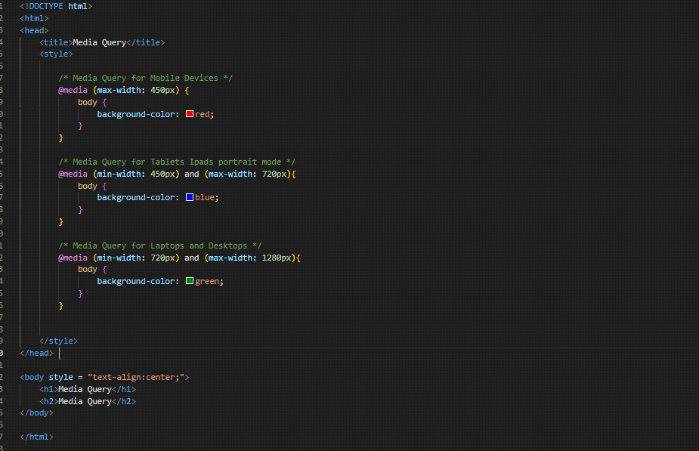
19) What is the rule set?
Answer : A CSS rule set contains one or more selectors and one or more declarations. The selector(s), which in this example is h1 , points to an HTML element. The declaration(s), which in this example are color: blue and text-align: center style the element with a property and value.
The “.” in the beginning indicates that the rule created will be a class, also “container” indicates the name of the selector. Similarly “first-child” indicates the pseudo-class, and elements inside curly brackets are elements of a declaration block, which contains some CSS properties and their corresponding values. The CSS ruleset will be applied when the selector name is called on the main HTML page.
But really, there are three important things to remember in the anatomy of a rule set: the selector, the property, and the value.
The selector is of 2 types, namely, id selector denoted by hash(#), used to apply the property having the unique id. The second is a class selector denoted by dot(.), used to select all elements which belong to a particular class attribute.
The key is property name & the value is property value, both the key and values are case-insensitive by default in CSS.
The portion in which the curly braces & the properties are declared is declaration block.

